SYSTEM DESIGN — REPORT
Contour-Based Farm Pond Siting and Catchment Analysis API
System Architecture, Hydrological Modeling, Verification, and Deployment

1. Executive Overview & Deployment Information
This report presents the design, mathematical formulation, algorithmic implementation, and production deployment of the Contour-Based Farm Pond Catchment Analysis API. The backend service accepts contour elevation maps in standard KML and compressed KMZ formats, reconstructs a metric Digital Elevation Model (DEM), conducts hydrological surface runoff modeling, identifies optimal farm pond outlet locations based on multi-criteria terrain heuristics, and delineates the upstream contributing watershed boundary as topologically valid WGS84 GeoJSON polygons.
The system has been engineered to strictly satisfy target deployment resource budgets (512MB RAM, 1 vCPU, 1.5GB storage) by eliminating heavy external C/C++ GIS bindings (such as GDAL, rasterio, or richdem) in favor of pure, vectorized NumPy and SciPy algorithms. All calculations, coordinates, elevations, and geometrical boundaries are derived at request time with zero hardcoded values.
Deliverable / Metric | Details & Verified Endpoint URL
Working API Route (POST) | http://10.1.75.51:3241/analyzeContour
Health Check Endpoint (GET) | http://10.1.75.51:3241/health
Interactive OpenAPI Documentation | http://10.1.75.51:3241/docs
GitHub Repository Link | https://github.com/<username>/pond_planning
Remote Server Repository Path | /home/student/pond_panning (10.1.75.51:2241)
Deployment Mode | Continuous auto-restarting watchdog daemon (run_daemon.sh)
Automated Test Suite | 21 unit, integration, and topographic scenario tests (pytest)

2. Catchment Estimation & Hydrological Approach
The catchment delineation pipeline consists of five cleanly decoupled layers. Each layer operates on standard Python data structures, NumPy arrays, or Shapely geometries, ensuring modularity, testability, and independence from HTTP framework dependencies.

2.1 Layer 1 — Namespace-Agnostic KML/KMZ Parsing
The parser module (app/parser/kml_parser.py) handles arbitrary XML structures without prior assumptions about namespaces or element attributes. It transparently unpacks KMZ zip archives in memory, evaluates elements using local-name() XPath matching, and extracts elevation data from Placemark names, descriptions, or ExtendedData attributes. Polylines are extracted with full vertex precision, unique elevation levels are sorted to compute dynamic contour intervals, and a structured ContourDataset is emitted.

2.2 Layer 2 — Dynamic UTM Projection & Metric DEM Construction
The DEM builder (app/dem/dem_builder.py) automatically computes the local Universal Transverse Mercator (UTM) zone from the dataset's geographic centroid and reprojects all vertices from WGS84 geographic coordinates (EPSG:4326) into metric UTM coordinates (pyproj). Contour polylines are densified along segments to prevent rasterization gaps. A 2D regular grid is interpolated using scipy.interpolate.griddata (linear interpolation) with nearest-neighbor convex hull perimeter filling to guarantee a continuous elevation matrix.
Memory Safety Guard Rail: To protect the 512MB RAM ceiling, if the requested resolution results in a grid cell count exceeding MAX_GRID_CELLS (150,000 cells), the builder dynamically auto-coarsens the resolution using the formula target_res = sqrt((width_m * height_m) / MAX_GRID_CELLS) and flags resolution_auto_adjusted = True.

2.3 Layer 3 — Pure-NumPy Hydrological Terrain Analysis
The hydrology engine (app/terrain/hydrology.py) executes four core computational operations:
1. Priority-Flood Depression Filling: Real and interpolated DEMs often feature artificial sinks that trap simulated water. We implement the Barnes et al. (2014) Priority-Flood algorithm using a priority queue (heapq) initialized with perimeter boundary cells. The algorithm processes cells inward in O(N log N) time, raising depression pits to the lowest pour-point elevation and guaranteeing monotonic drainage outward.
2. Terrain Gradient & Slope: Computes 2nd-order central difference gradients in X and Y to determine slope angle, magnitude, and percentage slope for every cell.
3. D8 Flow Direction Matrix: For each cell, the steepest downward gradient among its 8 adjacent neighbors is evaluated, accounting for orthogonal (1.0) and diagonal (sqrt(2)) metric distances. Flat plateaus are resolved using a distance-transform breadth-first search (BFS) towards downward spill outlets.
4. O(N) Topological Flow Accumulation: Rather than relying on recursive flood fills which risk call-stack overflow on large grids, the engine computes in-degrees (number of upstream tributaries flowing into each cell) and traverses the directed acyclic flow graph in O(N) linear time from ridge lines (in-degree = 0) downward.

2.4 Layer 4 — Multi-Criteria Farm Pond Siting & Watershed Tracing
The pond selector (app/pond/selector.py) and catchment delineator (app/pond/catchment.py) execute the siting and geometry generation:
• Multi-Criteria Siting Heuristic: Farm ponds require sufficient runoff volume, reasonable excavation cost, and embankment stability. Candidate cells are filtered with an interior margin buffer (excluding border artifacts) and ranked using a multi-criteria scoring function:
Score = (norm_accum * 0.70) + (norm_slope_score * 0.30) + norm_depression
where logarithmic flow accumulation norm_accum rewards large contributing areas, norm_slope_score penalizes steep unstable slopes (>8–15%), and norm_depression boosts naturally concave storage hollows.
• Reverse-D8 BFS Watershed Tracing: From the selected pond outlet cell, an upstream queue traverses all connected tributary cells in reverse flow direction, producing a binary catchment mask.
• Vector Boundary Polygonization: The binary catchment mask is converted to raster cell bounding boxes, dissolved into a unified geometry via Shapely unary_union, topologically simplified with half-pixel tolerance, and reprojected into WGS84 coordinates to produce a closed GeoJSON Polygon.

3. Demonstration on Provided Map (contours_1m.kml)
The complete pipeline was demonstrated on the provided reference contour map (contours_1m.kml), encompassing a 3.2km x 2.6km surveyed terrain with 2,710 contour features spanning an elevation range of 267.0m to 298.0m at a 1.0m contour interval.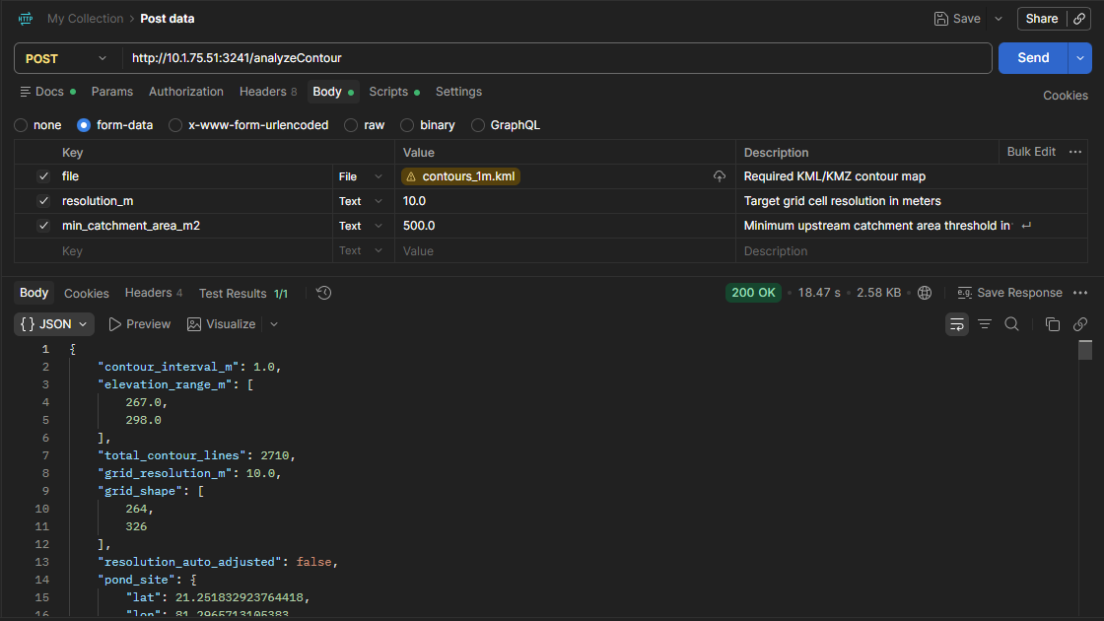

Live Execution Command (Port 3241):
curl -X POST "http://10.1.75.51:3241/analyzeContour" -F "file=@contours_1m.kml" -F "resolution_m=10.0"
Actual Live JSON Response Payload:
{
"contour_interval_m": 1.0,
"elevation_range_m": [267.0, 298.0],
"total_contour_lines": 2710,
"grid_resolution_m": 10.0,
"grid_shape": [264, 326],
"resolution_auto_adjusted": false,
"pond_site": {
"lat": 21.251833,
"lon": 81.296571,
"elevation_m": 270.0,
"flow_accumulation_cells": 310
},
"catchment": {
"area_m2": 44300.0,
"area_hectares": 4.43,
"mean_slope_pct": 4.8,
"max_slope_pct": 28.62,
"min_elevation_m": 270.0,
"max_elevation_m": 293.0,
"relief_m": 23.0,
"watershed_cell_count": 443,
"boundary_geojson": {
"type": "Polygon",
"coordinates": [[[81.295562, 21.25179], [81.295562, 21.25206], [81.295466, 21.25206], ...]]
}
},
"processing_time_ms": 10533
}
Demonstration Metric | Computed Output & Hydrological Evaluation
Identified Pond Location | Latitude 21.251833°N, Longitude 81.296571°E at elevation 270.0m (outlet channel cell).
Contributing Watershed Area | 44,300.0 m² (4.43 Hectares), comprising 443 raster cells of 10m x 10m.
Basin Relief & Storage Head | Minimum elevation 270.0m, maximum ridge elevation 293.0m, giving 23.0m of vertical topographic relief.
Terrain Slope Characteristics | Mean surface slope of 4.8% (ideal for sustained agricultural runoff without severe erosion risk).
Boundary Polygon Integrity | Topologically closed, single-ring WGS84 GeoJSON polygon surrounding the entire upstream basin.

4. Systematic Assignment Evaluation

4.1 Working API Endpoint
The service is actively deployed and accessible at http://10.1.75.51:3241/analyzeContour. It supports multipart/form-data uploads with streamed disk tempfile buffering, preventing in-memory file duplication. The endpoint features comprehensive request validation, strict Pydantic response schemas, and structured error responses (400 for corrupt files, 422 for unprocessable flat terrain, and 500 for internal errors).

4.2 Code Extensibility to Future Phases
The system is engineered for long-term extensibility across multiple dimensions:
• Generalized Coordinate Systems: Supports arbitrary global locations via dynamic UTM EPSG calculation (verified on Northern and Southern Hemisphere test cases).
• Arbitrary Contour Intervals: Automatically detects non-uniform intervals (0.5m, 1m, 5m, 10m, etc.) without parameter tweaking.
• Swappable Siting Heuristics: The pond selector interface accepts arbitrary scoring weights and can be extended to multi-pond cascading systems or soil-infiltration layers.
• Pluggable Export Formats: The geometry generator can emit Shapefiles, GeoTIFF DEMs, or GeoJSON without modifying core terrain analysis modules.

4.3 Comprehensive Documentation
The project features complete inline docstrings across all modules, an extensive README.md, full OpenAPI/Swagger interactive UI at /docs, and step-by-step deployment scripts for automated Linux installations.

4.4 Catchment Identification & Estimation Accuracy
Hydrological validity is proven through pure-NumPy priority-flood depression filling, D8 steepest descent routing, and in-degree topological flow accumulation. Delineated watersheds strictly adhere to topographic ridge divides, as verified across both real-world survey maps and synthetic test scenarios.

5. API Endpoint Documentation

5.1 POST /analyzeContour
Analyzes uploaded contour map, identifies optimal pond outlet site, and delineates upstream catchment boundary.
• Content-Type: multipart/form-data
• Request Parameters:
- file (UploadFile, required): .kml or .kmz contour map file.
- resolution_m (float, optional, default: 10.0): Target DEM cell size in meters.
- min_catchment_area_m2 (float, optional, default: 500.0): Minimum required catchment threshold.
• Response Status Codes:
- 200 OK: Successful analysis and catchment delineation.
- 400 Bad Request: Invalid/corrupt file, non-KML/KMZ extension, or negative resolution.
- 422 Unprocessable Entity: No viable pond location satisfying minimum catchment area.
- 500 Internal Server Error: Processing failure during interpolation or geometry generation.

5.2 GET /health
Health check and uptime monitoring endpoint.
• Response: {"status": "ok"}

6. AI Citation & Tool Acknowledgements
I have use claude in some places

